SOURCES OF FINANCE FOR MICROFINANCE INSTITUTIONS IN AFRICA
John Karuitha and Kalu Ojah
ABSTRACT
We examine the drivers of three indicators of financial structure for microfinance institutions in Africa: debt-equity ratio, deposits-assets ratio, and capital-assets ratio. The analysis shows that at the firm level, size, age, legal status, and profitability drive financing alternatives. Country-level institutional quality only matters for deposits mobilization. Financial development and education do not have a positive relationship with leverage, capital, and deposits, going against stylized facts on firms’ financing structure. Asset structure has a significant relationship only with leverage. The results imply that it is firm-level factors that are most relevant to the financing structure of MFIs in Africa. The results suggest a weak linkage between microfinance and the macroeconomy in Africa.

Introduction
Bayai and Ikhide (2016) cite the institutional theory in explaining the sources of finance for microfinance institutions in Africa. They note that at the early stages, most MFIs tend to operate as NGOs. These NGOs derive most of their funding from donations and concessionary funds, given that commercial funders deem them too risky (Ledgerwood, 1998; Ledgerwood & White, 2006). Later, in the consolidation stage, the NGOs supplement their funds using government subsidies and equity funding. As they mature, they resort to deposits and debt, regularly using foreign donors as guarantees. It is at this stage that MFIs are likely to mutate from NGOs that focus on social performance to the commercial model where financial sustainability matters as much as social performance.

Indeed, across the globe and in Africa, many MFIs are transitioning from the NGO not-for-profit model to the financial sustainability approach where they strive to generate profit over and above meeting their social goal (Hudon, 2010; Wagenaar, 2012; Kodongo & Kendi, 2013). Having grown on a donations dependent model, the shift to the commercial model has implied a shift in the business model, and most importantly the source of a steady source of funds (D’Espallier, Hudon, & Szafarz, 2013).

The transformation of MFIs from NGOs to the commercial model has raised concern over mission drift, where MFIs focus more on profitability and less on the social aspect of reaching the unbanked (Mia & Lee, 2017; Ramus & Vaccaro, 2017). Also, some researchers argue that the business model of most MFIs makes it difficult to integrate them into the formal financial system as financiers may deem them too risky for a given level of return (Campion & White, 1999). The argument for the institutional transformation of MFIs from the NGO, not-for-profit model is access to capital markets. Advocates of the commercial model of MFIs posit that capital market funding allows for improved corporate governance and reduces dependency on volatile donor funding (Garmaise & Natividad, 2013; D’Espallier, Hudon, & Szafarz, 2017), allowing MFIs to reach more unbanked people in the long run (Tchakoute-Tchuigoua, 2010). Both models continue to coexist.

This article examines the factors that determine the source of financing for MFIs in Africa. Specifically, we examine the drivers of leverage (debt to equity ratio), capital to assets ratio (also termed as equity to assets ratio), and finally, deposits to assets ratio. The contribution from this line of inquiry is significant for two reasons. First, MFIs are hybrid organisations that strive to offer a social good over and above, delivering financial results. Hence, the drivers of financing for MFIs may differ from those of purely commercial firms because the social goals of MFIs may be at conflict with those of the commercial providers of funds.

Secondly, dependent on the philosophical underpinnings of the MFI, not all strive to generate profits, focusing instead on the provisioning of financial services (on account of fulfilling the social mission of financial inclusion). The welfare approach or NGO model is still a dominant force in the MFI industry (Sarma, 2011; Jia, Cull, Guo, & Ma, 2016). It is paramount then to examine the ways that different models of MFIs provision source both long term and even short-term financing. The existing literature on capital structure choices focuses on commercial (profit-oriented) firms(Liu, Liu, Peng, & Yang, 2017). We believe that an examination of hybrid and socially oriented firms could offer additional insights. Such knowledge would, in turn, permit us to evolve more effective funding strategies to support and enable the unique added benefit of MFIs (that is, financial inclusion for the poor) that is particularly significant for emerging and developing economies.

The next section highlights the results of the study, followed by a review of theory and empirical literature. We then describe data and data sources, followed by the method. We discuss the results and then conclude.

Summary of Results
Size, profitability, legal status, and the age of MFIs in Africa are the consistent determinants of the three measures of financial structure: debt to equity ratio (leverage), capital to assets ratio and deposits to assets ratio. These results are consistent with the capital structure theory (Barclay & Smith, 2005; Ojah & Pillay, 2009). However, going against stylized theoretical facts (Allen et al., 2014), financial development and education are not critical determinants in the financing structure of MFIs in Africa. The size of MFIs, captured using the logarithm of assets, varies positively with debt to equity ratio, negatively with capital to assets ratio, but is not a significant driver of deposits mobilization. Also, the profit margin has a negative relationship with leverage, a positive one on capital-assets ratio, but is insignificant in garnering of deposits. Credit Unions and Banks come first in leverage and deposits to assets ratio but trail in capital to assets ratio- where NGOs and NBFIs lead the way. The legal hurdles in deposits mobilization by MFIs reflect NGOs lower capacity to garner deposits (D’Espallier, Goedecke, Hudon, & Mersland, 2017). Young firms have more leverage implying they finance their assets using more capital. The result could be due to the correspondence between age and size (Gwatidzo & Ojah, 2009). Finally, asset structure has a negative relationship with leverage but an insignificant driver of capital and deposits, a result that goes against a direct link between asset tangibility and leverage (Campello & Giambona, 2011). Overall, the results suggest that for MFIs in Africa, firm-level factors matter more in financing structure than macroeconomic factors.

Theory and Related Literature
Theory: pecking order theory
Signaling theory
Institutional life-cycle theory
Empirical literature

Method
The study adopts the fixed and random effects models depending on the outcome of the Hausman tests (see appendix 2). Following Roberts and Whited (2013), consider a model that follows.
<1>
Further, assume that,
<2>
Where captures the aggregate effects of the unobserved, time-invariant explanatory variables for . Further, assume that has zero mean conditional on . In the case where and are correlated, then is a fixed effect; otherwise, it is a random effect. Note that the existence of fixed effects implies the presence of endogeneity. For random effects, on the other hand, endogeneity is not a concern. However, the random-effects model affects the computation of standard errors (Roberts & Whited, 2013).

Thus, the fixed effects models seek the causes of changes within an entity. The fixed-effects model does this by controlling for all time-invariant differences between the individuals, so the estimated coefficients of the fixed-effects models cannot be biased because of omitted time-invariant characteristics, such as culture (Torres-Reyna, 2007). To deal with the endogeneity inherent in the fixed effects model, researchers recommend two strategies. The first approach involves the inclusion of firm-specific intercepts by running the least squares dummy variable regression. The approach is not feasible with medium to large datasets. In the alternative within-estimator approach, researchers apply OLS to the deviations-from-the-within estimator, which eliminates the fixed effect that is prone to endogeneity. The within-estimator regression is as follows.
<3>
The model does not deal with the potential endogeneity between and . Besides, differencing reduces the efficiency of the estimates if there is a correlation between the fixed effect (differenced out of the model) and the dependent variable (Clark & Linzer, 2015). Consequently, we run both fixed and random effects, even where the Hausmann test recommends one over the other.

4.1 Variables Definitions and Data Sources
We source panel data from the Microfinance Information Exchange (MIX) pooled database, the Worldwide Governance Indicators (WGI), and World Development Indicators (WDI) from the World Bank databases. Table 1 below describes the variables.
Table 1: Variables Definitions and Data Sources
Variable | Variable Description and Data Sources  (All data from MIX unless stated otherwise (*)
Debt to Equity Ratio | The ratio of total liabilities to equity, the capital contributed by shareholders. The ratio shows the way an MFI finances its portfolio and assets and the cushion to absorb losses after paying off all liabilities.
Deposits to Total Assets | The ratio of deposits to assets that aids in determining the extent to which MFIs use deposits to finance assets.
Capital Assets Ratio | Capital Assets Ratio is the ratio of total equity to total assets, the reciprocal of the debt to equity ratio above. Hence, it captures the ability to meet obligations and to absorb unexpected losses (Kimmel, Weygandt, & Kieso, 2018).
Assets | Assets are the sum of capital and liabilities- the total value of resources owned or controlled by the MFI resulting from past events and from which the MFI will derive future benefits. We expect firms with more assets to have a higher debt capacity and hence more debt to equity ratio and lower capital to equity ratio. Besides, these firms would attract more deposits, given the trust they inspire in depositors and marketing reach (Kimmel et al., 2018).
KKM - Institutional Quality (*) | We create the country level KKM index using the first principal component of the WGI available in the World Bank databases. The index captures the institutional quality in corruption control, government effectiveness, political stability, government effectiveness, the rule of law, and voice and accountability (Kaufmann, Kraay, & Mastruzzi, 2011). Firms in countries with better governance can quickly raise debt finance due to ease of contract enforcement — the result, a high debt-equity ratio, and a low capital asset ratio. Similarly, the level of deposits mobilisation may be higher in better-governed countries arising from consumer confidence in legislation relating to deposits protection (La Porta, Lopez-de-Silanes, & Shleifer, 2013; Allen et al., 2014).
Education (*) | Education is the ratio of gross secondary school enrolment to gross primary school enrolment that captures the extent of graduation from elementary to secondary education and the overall literacy rate. The data is available in the WDI. We hypothesise a positive relationship between education and debt/equity ratio, which implies a lower capital asset ratio. Similarly, education may enhance the capacity of the populace to use financial products like savings, and hence a higher deposit to assets ratio. Also, education may directly or indirectly influence financial sector development, which eases the acquisition of capital in financial markets(Allen et al., 2014).
Financial Development (Fdev) (*) | Fdev represents the financial resources provided to the private sector by domestic money banks as a share of GDP. Domestic money banks comprise commercial banks and other financial institutions that accept transferable deposits, such as demand deposits. The data is available in WDI. Financial sector development is central to the acquisition of both equity and debt financing. We hypothesise a high debt to equity ratio, and deposits to assets ratios in countries with more robust financial sectors as financial institutions tend to be highly leveraged.
Asset Structure | Asset structure is the ratio of non-current assets to total assets of an MFI. The ratio indicates the extent of investment in physical infrastructure- a significant issue in banking for the poor due to the perceived lack of scale economies to warrant the erection of, for instance, brick and mortar branches. MFIs with a more significant physical presence are likely to attract more deposits. They hence also have a higher capacity to borrow and service debt.
Profit margin | The profit margin is the net operating income divided by financial revenue. The ratio represents the ability of MFIs to generate income from the core mandate of offering financial services like lending, savings, insurance. Profitability may enhance the capacity of an MFI to secure debt leading to a higher debt to equity ratio and low capital to assets ratio. The opposite is the case when an MFI retains earnings and hence raises the level of equity.
Age | MIX classifies MFIs into three categories depending on the time elapsed since the MFI started operations- new (0-4 years), young (4-8 years) and mature (over eight years). The variable is hence a dummy. Older firms are likely better established, have a solid reputation and hence likely to attract more debt and deposits.
Current Legal Status | The legal form of registration of an MFI- Commercial Bank, Non-Bank Financial Institution (NBFI), Non-Governmental Organization (NGO), Credit Union/ Cooperative, or Rural Bank. The legal status may dictate the profit orientation and sources of capital for the MFIs. The legal status of an MFI may impact the financing structure in several ways. First, legal restrictions typically restrict NGOs from taking deposits which lowers both the debt-equity ratio and deposit to assets, hence raising the capital asset ratio. Also, NGOs may not venture into capital markets for funds given their mostly not-for-profit orientation. The opposite is the case for MFIs like commercial banks whose legal status allows for deposits.
Source: Adapted from MIX, WDI and WGI Databases

Exploratory Data Analysis
Figure 1 shows the correlation matrix and scatter plots for the numeric variables used in the model. Debt-to-equity ratio, deposits-to-assets ratio, and capital-to-assets ratio (the first three entries of the rows and columns) are the dependent variables. The rest are the independent variables. The main diagonal shows the distribution of variables – in place of correlation of a variable with itself. The diagonal shows that most variables are highly skewed, except for assets. To normalise the data, we take the logarithms of these variables. The lower half of the table shows the pairwise scatter plots between the variables, with the axis interpreted as we do correlation matrices described next.

The upper section of the table contains the correlation matrix. For dependent variables, there is a substantial negative and significant relationship between capital-asset-ratio (which captures the ratio of equity capital to total assets) and deposits-assets-ratio. The correlations indicate that for MFIs that garner deposits, the injection of equity capital is not a priority as these MFIs, like commercial banks, tend to leverage on deposits and just put in enough equity to meet regulatory requirements. Debt-equity ratio and deposit-asset ratio have a significant positive relationship, although the magnitude is not high. Capital-asset ratio and debt-equity ratio have no significant relationship. For the dependent variables, the interpretation is similar- with high correlations notable between education, KKM- institutional quality, and capital market development (FINDEV).

Finally, as we expect, a few independent variables have significant relationships with the dependent variables. Specifically, for the debt to equity ratio, only financial development is not significant. The observation is a puzzle given that Africa mostly follows a bank-based model as opposed to the capital markets-based model of financing enterprises. For deposits to assets ratio, all the independent variables are essential except the profit margin. The capital asset ratio lacks a significant relationship with profit margin, asset structure, and financial development. While correlation does not imply causation, these results point to the need for further investigation that we do the section on regression models where we shall revisit this result to allow for an in-depth interrogation of the pertinent issues arising. Table () shows the summary statistics for the variables and, importantly, the results of stationarity tests.

Figure 1: Scatter Plots and Correlation Matrix for Numeric Dependent and Independent Variables
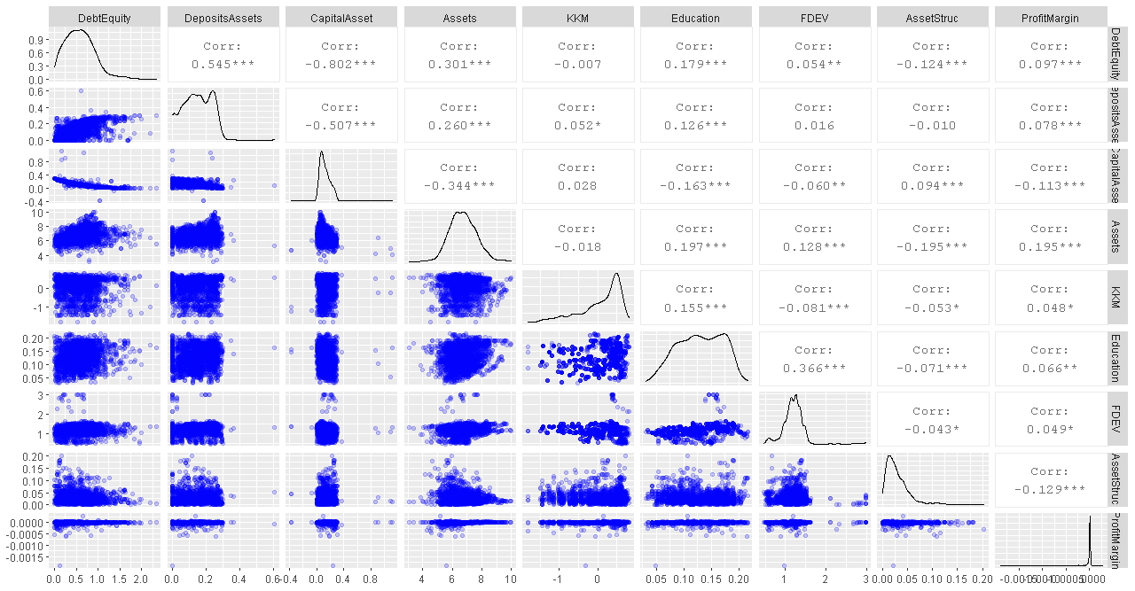
Source: Authors’ construction from the MIX dataset
Table 2: Summary Statistics
Variable |  | N | Mean | SD | Min | Quartile1 | Median | Quartile3 | Max | Stationarity
 |  |  |  |  |  |  |  |  |  | Chi-Square
Debt to Equity Ratio |  | 4543 | 3.93 | 28.93 | -440.87 | 0.84 | 2.39 | 5.01 | 585.24 | 2431.177***
Deposits to Total Assets |  | 4378 | 0.45 | 0.60 | 0.00 | 0.17 | 0.40 | 0.67 | 20.99 | 1371.861***
Capital Assets Ratio |  | 4676 | 0.32 | 0.61 | -18.35 | 0.15 | 0.27 | 0.49 | 12.15 | 2513.218***
Assets |  | 4693 | 6.49 | 0.99 | 0.00 | 5.87 | 6.45 | 7.14 | 9.98 | 1844.833***
KKM - Institutional Quality |  | 4491 | 0.01 | 2.06 | -5.23 | -1.40 | -0.21 | 1.72 | 7.37 | 1330.653***
Education |  | 4312 | 0.39 | 0.15 | 0.07 | 0.27 | 0.38 | 0.49 | 1.05 | 2033.682***
Financial Development (fdev)** |  | 4628 | 20.84 | 54.31 | 0.35 | 9.94 | 14.77 | 20.76 | 972.21 | 1801.3872***
Asset Structure (log)** |  | 4161 | 0.08 | 0.07 | 0.00 | 0.03 | 0.06 | 0.10 | 0.86 | 1590.121***
Profit margin |  | 4414 | 0.00 | 0.05 | -3.55 | 0.00 | 0.00 | 0.00 | 0.00 | 3819.894***
Age (Dummy) |  | 4782 | - | - | - | - | - | - | - | -
Current Legal Status (Dummy) |  | 4782 | - | - | - | - | - | - | - | -
Country (Dummy) |  | 4782 | - | - | - | - | - | - | - | -
Year |  | 4782 | - | - | 1999 | - | - | - | 2019 | -
- We ran the Fisher type unit root tests based on the augmented Dickey-Fuller tests of stationarity that can handle instances of missing data points in a panel setting. Hypotheses: HO: All panels contain unit-roots H1: At least one panel is stationary.
- DUMMIES: The other variables absent in the unit root test are dummies- current legal status, and age, region.
- Financial development (fdev) became stationary after taking the first difference.
- The log of assets was stationary.
Source: Authors’ constructions from MIX data
Figure 2: Dependent Variables vs Age and Legal Status of MFIs in Africa
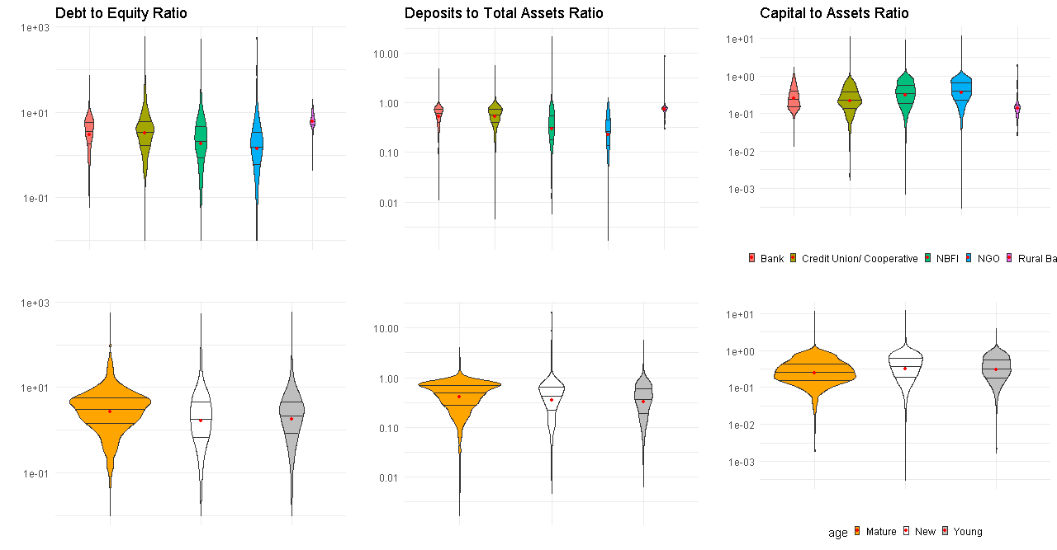 Source: Authors’ construction from the MIX Dataset
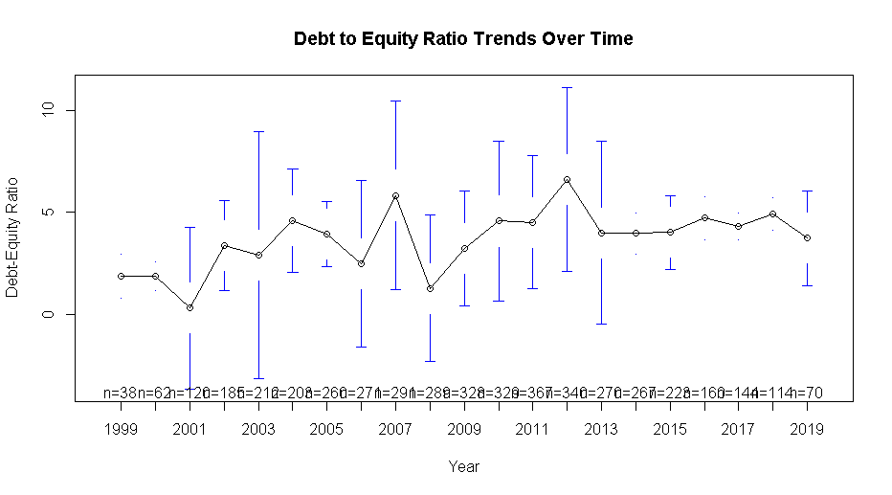 | 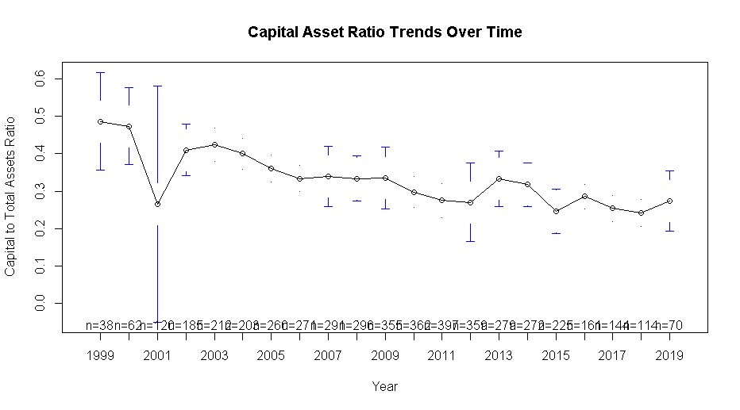 | 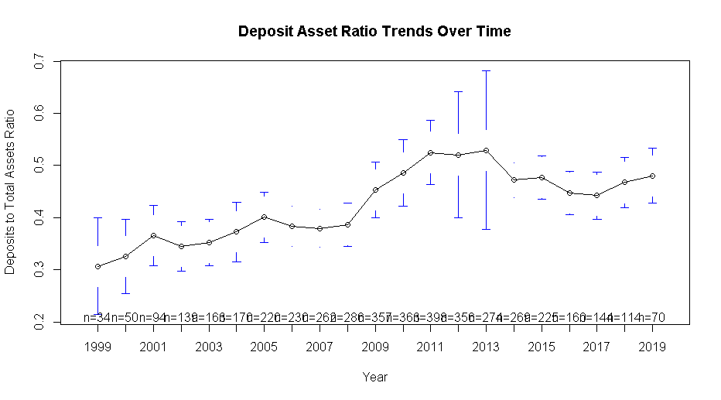
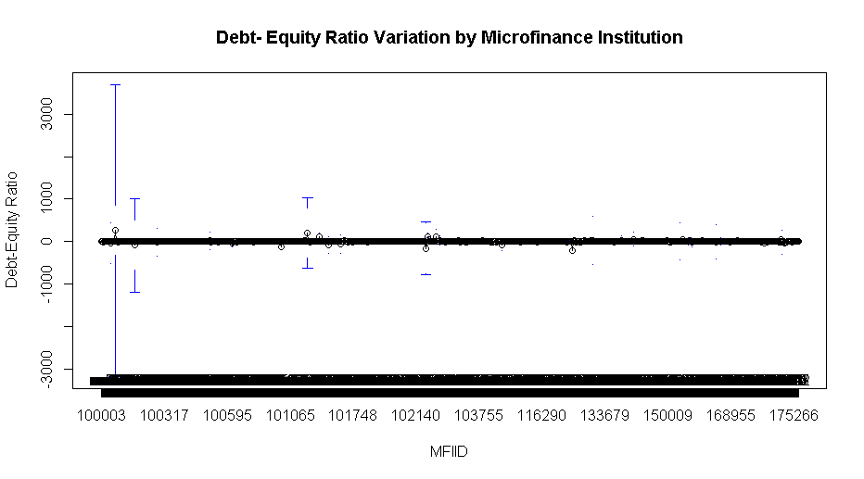 | 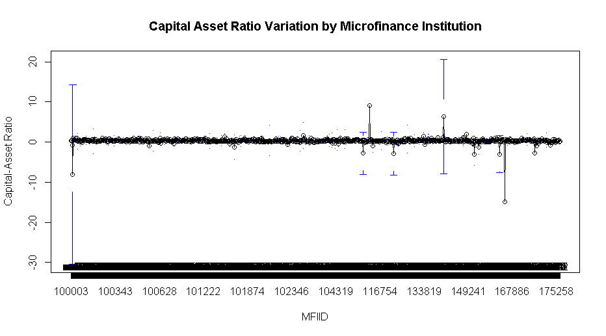 | 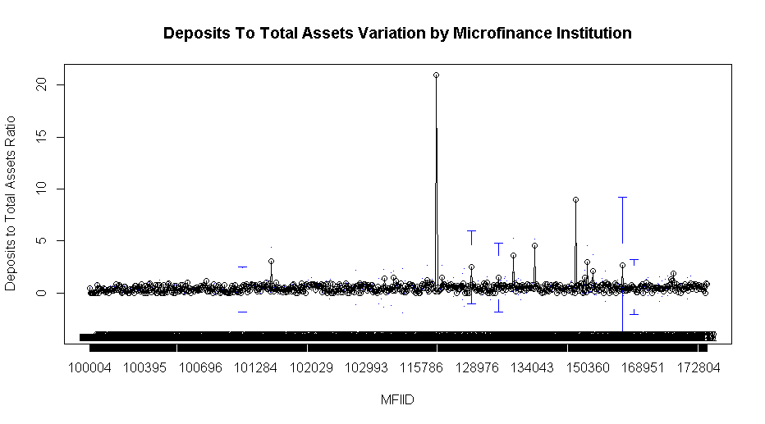

Figure 3: Cross-Sectional Variation and Time Trends of Dependent Variables

Regression Results
The next section provides a discussion on the output from the regression models starting with the debt-equity ratio (random-effects model), the deposits to total assets ratio (random-effects model), and finally, the capital to assets ratio (fixed-effects model). Appendix () shows the results of the Hausmann Test and the choice over fixed and random effects models.

6.1 Drivers of Leverage (Debt-Equity Ratio) in Microfinance Institutions
Table 3 shows the output of regression models. The data at hand is an unbalanced panel. First, we ran a random-effects model on the full dataset. We then subset the data for instances with three or more years of data and then five or more years of data. These figures (three and five) correspond to the mean and median number of years of data per MFI in the dataset. Finally, we run a pooled OLS and a fixed-effects model using the full dataset. The regressions indicate that at the firm level, the size, profit margin and age matter the most in determining the debt-equity ratio.

Larger MFIs with more assets tend to have a higher debt to equity ratio, holding other variables in the models constant. In this case, a 1% rise in assets corresponds to a 6% - 8% rise in leverage going by the random-effects model. The fixed-effects model indicates a modest 3.5% change. The result is consistent with the theory. Large firms can use the assets as collateral for debt and usually tend to be well established with a solid credit history and hence can quickly source funds in the capital markets (Campello & Giambona, 2011; Ojah & Ombati, 2016).

On the other hand, MFIs with higher profit margins have less debt to equity ratio, with a 1% rise in profits corresponding with between 5.8% and 7.8% drop in leverage. In this case, MFIs could be utilising the profits to pay dividends and retained earnings, with the retained earnings counting as equity, which lowers the debt to equity ratio. Moreover, MFIs with higher profit margins have less pressure to borrow to bridge financing shortfalls, opting, instead, to maintain a higher reserve borrowing capacity (Barclay & Smith, 2005; Ojah & Pillay, 2009). The result is in line with the pecking order theory of capital structure, where firms prefer to raise funds internally before seeking external equity and debt. Also, firms with viable investment options but facing internal funds deficiency, tend to issue more debt (De Jong, Verbeek, & Verwijmeren, 2011). Ceteris paribus, asset structure, the ratio of non-current assets to total assets, relates negatively to leverage. However, the significance of the result is not consistent across models. These results suggest that firms that commit to fixed investments do so using equity – meaning that MFIs prefer financing expansion using equity instead of debt.

The legal status of an MFI also appears to impact on leverage marginally. Specifically, except for credit unions/ cooperatives, commercial banks tend to have more leverage than NGOs and NBFIs – although the result is not significant for the latter two. The result could arise due to banks being well established and hence able to access the debt market easily. Cooperatives tend to have a limited geographic scope and restricted membership and rely mostly on members deposits (Pashkova et al., 2016). NGOs, on the other hand, focus more on the social aspects of microfinance (Tchakoute-Tchuigoua, 2010), which could negatively impact their credit rating.

Furthermore, in pursuing social goals, NGOs draw donations and subsidies (D’Espallier, Goedecke, et al., 2017). However, with the increased adoption of the for-profit model by NGOs, coupled with the ability to raise deposits, the gap is blurring (Chahine & Tannir, 2010). Finally, older firms tend to have higher leverage than younger ones, which could be directly related to credit rating quality and having more collateral on account of maturity.

Table 3: Regression output for Debt to Equity Ratio
Dependent Variable: Debt to Equity Ratio
Term | Random Effects  (Full dataset) | Random Effects  (years >= 3) | Random Effects  (years >= 5) | Pooled OLS  (Full Dataset) | Fixed Effects  (Full Dataset)
(Intercept) | -0.1129 | -0.1910 | -0.1816 | -1.1342*** | -
Size (Log of Total Assets) | 0.0669** | 0.0773** | 0.0821** | 0.1260*** | 0.0350
Institutional Quality (KKM) | 0.0113 | 0.0094 | 0.0000 | 0.0326 | 0.0054
Education | 0.1934 | 0.1734 | 0.1849 | 0.1327 | 0.1148
Financial Dev (d_fdev) | 0.0017 | 0.0016 | 0.0018 | 0.0034 | 0.0012
Asset Structure | -0.8359 | -0.7491 | -0.4842 | -0.0618 | -1.5316**
Profit Margin | -0.0784*** | -0.0780*** | -0.0683*** | -0.1817*** | -0.0579**
Legal Status: Credit Union | 0.0962 | 0.0759 | 0.1065 | 0.1246** | -
Legal Status: NBFI | -0.0150 | -0.0076 | -0.0312 | -0.0083 | -
Legal Status: NGO | -0.0775 | -0.0562 | -0.0232 | -0.0029 | -
Age: New | -0.0933** | -0.1046** | -0.1035* | 0.0157 | -0.1301**
Age: Young | -0.0304 | -0.0307 | -0.0260 | 0.0260 | -0.0439
N
R-Squared | 0.2329 | 0.2057 | 0.2017 | 0.2226 | 0.1209
Adjusted R-Squared | 0.2062 | 0.1762 | 0.1691 | 0.1955 | -
DF | 30 | 30 | 30 | 30(861) | 27(673)
Chi-sq | 258.584*** | 207.9290*** | 184.7680*** | - | -
F-statistic | - | - | - | 8.2177*** | 3.4266***
Notes:
- We compute Panel Corrected Standard Errors (PCSE) that cater for cross-sectional dependence and generate heteroscedastic consistent coefficients, see section ().

At the country level, education and financial sector development do not appear to drive leverage significantly, ceteris paribus. These results contradict those of the literature on capital market development that stresses the place of both education and financial sector development in driving financing decisions, uniquely leverage (Ojah & Ombati, 2016; Matias & Serrasqueiro, 2017).

It is puzzling then that both education and financial development appear insignificant in the financing structure of MFIs. The explanation could be that most MFIs have minimal capital market participation, given their operating model. With this insight, financial development could still be an essential part of determining the leverage of business firms in general but fail to apply to MFIs. Allen et al. (2014) note that education is a crucial determinant of financial sector development in terms of enhancing capital market participation. Not surprising that the signs of the coefficients are both positive. Figure 1 indeed shows a significant correlation between financial development and education (36.6%). The result underlines the place of education in driving financial decisions among individuals and firms, more so in capital market participation as theory predicts(Allen et al., 2014).

6.2 Capital to Assets Ratio
Regression results for the drivers of the capital-output ratio among MFIs in Africa appear in Table 4. Capital assets ratio is the ratio of total equity to total assets and the inverse of debt to equity ratio. Going by the definition, we expect the inverse of the results obtained in section 7.1. Again, size, profit margin, and legal status are related to the equity to total assets ratio. A 1% change in the size of an MFI corresponds to a 3% reduction in capital to assets ratio. At the same time, profit margin appears to have a one to one relationship with capital assets ratio. Profit margins correspond to more retained earnings, giving a boost to internal equity. On the other hand, large firms would have a lower propensity to retain earnings given their capacity to access capital markets.

Asset structure, financial sector development and education are not significant factors. Compared to mature firms, new and young MFIs have a higher capital to assets ratio. New MFIs have a higher capital to assets ratio compared to young MFIs. The implication is that new entrants finance their operations using equity – mostly internal equity, mostly retained earnings given that capital market development is not a significant determinant of capital asset ratio.

The results also reflect the market conditions where donations and subsidies are getting less available as donors begin to stress sustainability. Mature firms have a long-running relationship with donors and hence rely more on subsidies and donations relative to equity capital. NGOs and NBFIs have higher equity to assets ratio compared to commercial banks- with NGOs having the highest capital to assets ratio. There is no significant relationship between cooperatives and their capital to assets ratio. However, the sign of the coefficient is negative, meaning commercial banks tend to have more equity than cooperatives. Characteristically, commercial banks tend to be more leveraged compared to other financial intermediaries because they have the license and scale to garner deposits and other debt instruments, which could explain the pattern of results.

Table 4: Regression output for Capital to Total Assets Ratio
Dependent Variable: Capital to Total Assets Ratio
Term | Fixed Effects  (Full dataset) | Fixed Effects  (years >= 3) | Fixed Effects  (years >= 5) | Pooled OLS  (Full Dataset) | Random Effects  (Full Dataset)
(Intercept) | - | - | - | -1.1342*** | 0.3617***
Size (Log of Total Assets) | -0.0267** | -0.0114 | -0.0104 | 0.1260*** | -0.0266***
Institutional Quality (KKM) | 0.0003 | -0.0005 | -0.0004 | 0.0326 | -0.0018
Education | -0.0427 | -0.0308 | -0.0325 | 0.1327 | -0.0366
Financial Dev (d_fdev) | -0.0005 | -0.0007 | -0.0007 | 0.0034 | -0.0004
Asset Structure | 0.2466 | 0.2834* | 0.2606 | -0.0618 | -0.0335
Profit Margin | 0.0100* | 0.0094* | 0.0081 | -0.1817*** | 0.0168***
Legal Status: Credit Union | - | - | - | 0.1246* | -0.0196
Legal Status: NBFI | - | - | - | -0.0083 | 0.0057
Legal Status: NGO | - | - | - | -0.0029 | 0.0336***
Age: New | 0.0150 | 0.0179 | 0.0183 | 0.0157 | 0.0135
Age: Young | 0.0079 | 0.0080 | 0.0080 | 0.0260 | 0.0066
N
R-Squared | 0.1113 | 0.1283 | 0.1291 | 0.2312 | 0.2330
Adjusted R-Squared | - | - | - | 0.2045 | 0.2062
DF | 27(676) | 27(664) | 27(616) | 30(865) | 30
Chi-sq | - | - | - | - | 258.584***
F-statistic | 3.1355*** | 3.61818*** | 3.38193*** | 8.66835*** | -
Notes:
We compute Panel Corrected Standard Errors (PCSE) that cater for cross-sectional dependence and generate heteroscedastic consistent coefficients, see section ().

Deposits to Total Assets
The drivers of deposits to assets in MFIs are country-level institutional quality (KKM) and the legal status of the MFI. KKM relates negatively to deposit mobilisation, holding all other variables constant. These results would imply that as institutional quality improves, people are less likely to maintain deposits, and instead, prefer the capital markets and other sorts of investments. The argument will hold if KKM supports the development of financial and other markets that facilitates investments with better returns than bank deposits offer. Indeed, although mostly insignificant, the degree of capital market development has a negative relationship with deposits to assets ratio which could render credence to the argument.

The legal status of an MFI is another primary driver the deposit to total earnings ratio for MFIs. NBFIs and NGOs tend to have fewer deposits than commercial banks. For NGOs, the dearth of deposits could be due to legal restrictions on deposit mobilisation. Credit Unions, on the other hand, thrive on taking deposits from members who raise their capacity for deposits mobilisation compared to commercial banks. The results illustrate that although the macroeconomic environment supports greater deposits mobilisations, the extent of the mobilisation will vary depending on the nature of the MFI. Hence, the transformation of MFIs must consider the vision of the organisation. Other features that appear to have a relationship, albeit weakly so are assets structure and financial development, both of which have negative coefficients. The relationship, however, is not consistent across models.

Table 5: Regression output for Deposits to Total Assets Ratio
Dependent Variable: Deposits to Total Assets Ratio
Term | Random Effects  (Full dataset) | Random Effects  (years >= 3) | Random Effects  (years >= 5) | Pooled OLS  (Full Dataset) | Fixed Effects  (Full Dataset)
(Intercept) | 0.1668*** | 0.1474*** | 0.1758**** | -0.0256 | -
Size (Log of Total Assets) | 0.0013 | 0.0022 | 0.0028 | 0.0224*** | -0.0045
Institutional Quality (KKM) | -0.0079** | -0.0087** | -0.0057** | 0.0068 | -0.0102***
Education | 0.0095 | 0.0043 | -0.0001 | 0.0404 | -0.0177
Financial Dev (d_fdev) | -0.0002 | -0.0002 | -0.0094*** | -0.0007 | -0.0001
Asset Structure | -0.1109 | -0.1288 | 0.0196 | 0.3108 | -0.2495**
Profit Margin | -0.0006 | -0.0003 | -0.0002 | -0.0209** | 0.0008
Legal Status: Credit Union | 0.0065 | 0.0131 | 0.0251 | 0.0307 | -
Legal Status: NBFI | -0.0522*** | -0.0367* | -0.0419** | -0.0397** | -
Legal Status: NGO | -0.0723*** | -0.0563** | -0.0535** | -0.0321 | -
Age: New | 0.0033 | 0.0025 | -0.1850 | -0.0003 | 0.0032
Age: Young | -0.0057 | -0.0058 | 0.0006 | -0.0227 | -0.0035
N
R-Squared | 0.2443 | 0.1713 | 0.1756 | 0.2401 | 0.1142
Adjusted R-Squared | 0.2181 | 0.1408 | 0.1420 | 0.2138 | -
DF | 30 | 30 | 30 | 30(866) | 27(676)
Chi-sq | 279.5540*** | 168.344*** | 157.117*** | - | -
F-statistic | - | - | - | 9.1209*** | 3.2290***
Notes:
We compute Panel Corrected Standard Errors (PCSE) that cater for cross-sectional dependence and generate heteroscedastic consistent coefficients, see section ().

Robustness Checks
In this section, we highlight the robustness checks on the models run in three areas; extreme values (outliers), heteroscedasticity, autocorrelation, and cross-sectional dependence. In each case, we discuss the corrective measures taken.

7.1 Extreme values/ Outliers
The likelihood that extreme values could influence the results is highly likely in a panel setting containing different units. To check whether the outliers affect our inference, we winsorise the data by removing the top 10% and the bottom 10% for each variable used in the regression analysis. We then ran regression models on the new dataset with the results displayed in appendix 1. Like in prior regressions, size, and profit margin drive of the choice of financing, holding all other variables constant. Notably, both education and financial development remain less critical as drivers of choice of financing. Age and the legal status of MFIs remain essential contributors to the choice of financing sources.

7.2 Cross-Sectional Dependence, heteroscedasticity, and serial correlation
In panel data settings, cross-sectional dependence (CSD) is an important consideration. CSD arises when there is a correlation between units in the same cross-section, usually due to unobserved common factors that affect all units, although probably to differing extents. The omission of common factors in the model results in inconsistent estimates for fixed effects, random effects, and even the first difference model (Henningsen & Henningsen, 2019). In our case, we run the Breusch-Pagan LM test of independence with the results shown in appendix 4 and 5. The tests indicate the presence of cross-sectional dependence in the regressions with Capital to Total Assets Ratio and Deposits to Total Assets Ratio as the dependent variables.

Extant research deals with CSD in three main ways. The traditional method is the use of seemingly unrelated regressions (SUR) of Zellner and Huang (1962) (Arouri & Rault, 2013). SUR allows for the estimation of the individual coefficient β_{i} and hence estimate the effects of the independent variables on the dependent variables for each unit of analysis, in our case MFIs (Sarafidis & Wansbeek, 2012). Again, the cross-sectional data is not sufficient for SUR analysis. The second method developed by Pesaran and Smith (1995) - the panel mean groups- works by averaging individual coefficients across panels. The technique hence requires panel data where each panel has sufficient data for a regression, which is not possible in this study. Hence, we implement the third approach; the Panel Corrected Standard Errors (PCSE) (Bailey & Katz, 2011; Croissant et al., 2020). PCSE is useful when working with heterogeneous dynamic panel data by correcting for autocorrelation and cross-sectional dependence while providing more robust standard errors (Ikpesu, Vincent, & Dakare, 2019). The results presented have their standard errors corrected for CSD, resulting in heteroscedastic consistent coefficients.

Conclusion

References

Appendix 1: Regression output for Winsorized Data
 | DEPENDENT VARIABLES
TERM | DEBT TO EQUITY RATIO |  |  | CAPITAL ASSET RATIO |  |  | DEPOSITS ASSETS RATIO
 | Random  Effects | Pooled  OLS | Fixed  Effects | Random  Effects | Pooled  OLS | Fixed  Effects | Random  Effects | Pooled  OLS | Fixed  Effects
(Intercept) | -0.5137* | -1.1861*** | - | 0.3917*** | 0.5392*** | - | 0.1024** | -0.0871 | -
Size (Log of Total Assets) | 0.1118** | 0.1498*** | 0.0887 | -0.0306*** | -0.0366*** | -0.0287** | 0.0078 | 0.0313*** | -0.0003
Institutional Quality (KKM) | 0.0043 | 0.0279 | -0.0006 | 0.0003 | -0.0070 | 0.0033 | -0.0084** | 0.0061 | -0.0103**
Education | 0.0617 | 0.0446 | -0.0386 | -0.0193 | -0.0064 | -0.0070 | 0.0136 | 0.0534 | -0.0153
Financial Development (d_fdev) | 0.0019 | 0.0168* | -0.0005 | -0.0009 | -0.0034 | -0.0006 | -0.0019 | -0.0016 | -0.0019
Asset Structure | -0.4527 | 1.2663 | -1.7930* | 0.1319 | -0.3306 | 0.4703** | -0.2148* | 0.6396* | -0.3128**
Profit Margin | -0.0746*** | -0.1403*** | -0.0574** | 0.0157*** | 0.0319*** | 0.0121** | -0.0015 | -0.0186** | 0.0000
Legal Status: Credit Union | 0.1138* | 0.1088* | - | -0.0330** | -0.0268* | - | 0.0406* | 0.0470 | -
Legal Status: NBFI | -0.0207 | -0.0171 | - | -0.0016 | -0.0013 | - | -0.0305 | -0.0248 | -
Legal Status: NGO | -0.0319 | -0.0136 | - | -0.0031 | -0.0071 | - | -0.0358* | -0.0038 | -
Age: New | -0.0695 | 0.0171 | -0.1008* | 0.0155 | -0.0031 | 0.0224* | 0.0060 | -0.0124** | 0.0064
Age: Young | 0.0020 | 0.0476 | -0.0120 | -0.0016 | -0.0089 | 0.0012 | -0.0070** | -0.0248 | -0.0050
N | 718 | 718 | 718 | 720 | 720 | 720 | 720 | 720 | 720
R-Squared | 0.2522 | 0.2819 | 0.1391 | 0.2485 | 0.2855 | 0.1609 | 0.1970 | 0.2809 | 0.1303
Adjusted R-Squared | 0.2200 | 0.2505 | - | 0.2158 | 0.2544 | - | 0.1621 | 0.2496 | -
DF | 30 | 30(687) | 27(571) | 30 | 30(689) | 27(573) | 30 | 30(689) | 27(573)
Chi-sq | 230.4050*** | - | - | 227.241*** | - | - | 169.041*** | - | -
F-statistic | - | 8.9884*** | 3.4157*** | - | 9.1778*** | 4.0680*** | - | 8.9724*** | 3.1787***
Notes:
- We compute Panel Corrected Standard Errors (PCSE) that cater for cross-sectional dependence and generate heteroscedastic consistent coefficients.
- We winsorised out the top 10% and the bottom 10% of the data to remove outliers

Appendix 2: Results of the Hausman Tests of Fixed versus Random Effects
Dependent Variable | Statistic | Parameter | Method | Alternative | Model Choice
Debt to Equity | 56.75289*** | 27 | Hausman Test | one model is inconsistent | Random Effects
Capital to Total Assets | 14.82999 | 27 | Hausman Test | one model is inconsistent | Fixed Effects
Deposits to Total Assets | 55.17438*** | 27 | Hausman Test | one model is inconsistent | Random Effects
The tests derive from the regression models run using the full dataset.

Appendix 3: Breusch-Pagan Test for the Choice of Fixed/ Random Effects versus Pooled OLS
Dependent Variable | Statistic | Parameter | Method | Alternative
Debt to Equity | 711.5006*** | 1 | Lagrange Multiplier Test - (Breusch-Pagan) for unbalanced panels | Significant effects
Deposits to Total Assets | 1499.5848*** | 1 | Lagrange Multiplier Test - (Breusch-Pagan) for unbalanced panels | Significant effects
Capital to Total Assets | 5.92*** | 1 | F test for individual effects | Significant effects
In all cases, we utilise the full dataset in the analysis. We run the Breusch-Pagan LM test on the random-effects models.
As the hypothesis shows, the fixed/ random effects models fare better than pooled OLS in all instances.

Appendix 4: Testing for cross-sectional dependence/contemporaneous correlation- Breusch-Pagan LM test of independence and Pasaran CD test
Dependent Variable | Statistic | Parameter | Method | Alternative
Debt to Equity | 10077*** | 5300 | Breusch-Pagan LM test for cross-sectional dependence in panels | Cross-sectional dependence
Capital to Total Assets | 10227*** | 5339 | Breusch-Pagan LM test for cross-sectional dependence in panels | Cross-sectional dependence
Deposits to Total Assets | 10110*** | 5339 | Breusch-Pagan LM test for cross-sectional dependence in panels | Cross-sectional dependence
Serial correlation is a problem in the panel time series. Panel time series refers to datasets with a long time series component such that each panel could be subject to inference using a regression model. In our case, the mean number of panels is three (3) while the median is five (5), which we assume is below the threshold.

Appendix 5: Pasaran CD Test
Dependent Variable | Statistic | Method | Alternative
Debt to Equity Ratio | -1.1169 | Pesaran CD test for cross-sectional dependence in panels | Cross-sectional dependence
Capital to Total Assets Ratio | 5.574065*** | Pesaran CD test for cross-sectional dependence in panels | Cross-sectional dependence
Deposits to Total Assets Ratio | 5.058966*** | Pesaran CD test for cross-sectional dependence in panels | Cross-sectional dependence

Appendix 6: Variance Inflation Factors (VIF) for Pooled Regressions
DEPENDENT VARIABLES
 | Debt to Equity Ratio |  |  | Capital to Assets Ratio |  |  | Deposits to Assets Ratio
Variable | GVIF | DF | GVIF^(1/(2*Df)) | GVIF | DF | GVIF^(1/(2*Df)) | GVIF | DF | GVIF^(1/(2*Df))
Size (Assets) | 1.5425 | 1 | 1.2420 | 1.5499 | 1 | 1.2450 | 1.5442 | 1 | 1.2427
KKM | 1.2617 | 1 | 1.1233 | 1.2617 | 1 | 1.1232 | 1.2621 | 1 | 1.1234
Education | 1.4969 | 1 | 1.2235 | 1.4983 | 1 | 1.2240 | 1.4978 | 1 | 1.2238
Fin Dev | 1.0379 | 1 | 1.0188 | 1.0380 | 1 | 1.0188 | 1.0379 | 1 | 1.0188
Asset Structure | 1.1534 | 1 | 1.0740 | 1.1553 | 1 | 1.0748 | 1.1528 | 1 | 1.0737
Profit Margin | 1.0472 | 1 | 1.0233 | 1.0457 | 1 | 1.0226 | 1.0467 | 1 | 1.0231
Legal Status | 1.6462 | 3 | 1.0866 | 1.6357 | 3 | 1.0855 | 1.6438 | 3 | 1.0864
Age | 1.4095 | 2 | 1.0896 | 1.4056 | 2 | 1.0888 | 1.4014 | 2 | 1.0880
Year | 1.6043 | 19 | 1.0125 | 1.6093 | 19 | 1.0126 | 1.6086 | 19 | 1.0126

Source: Authors’ Construction from the MIX datasets

Appendix 7: Normality of Residuals
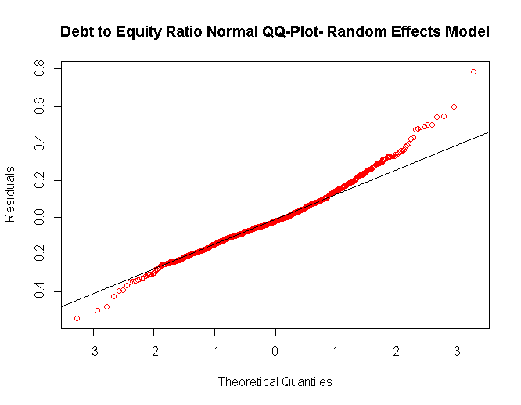 | 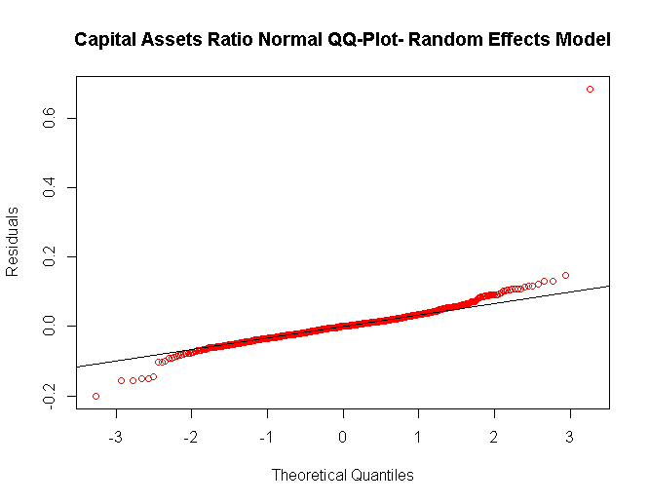 | 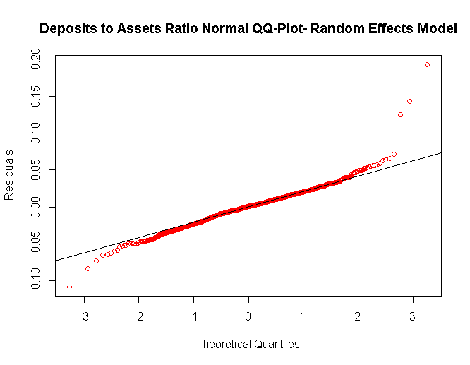
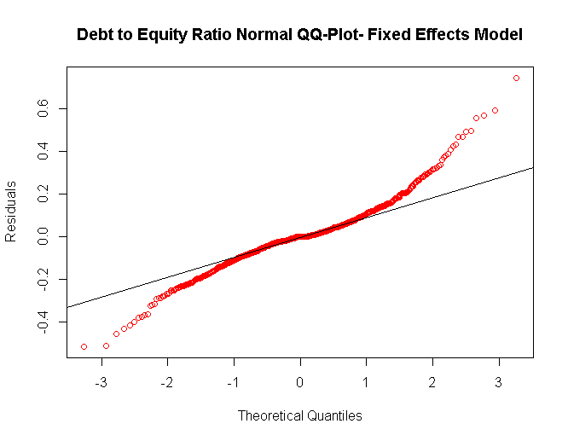 | 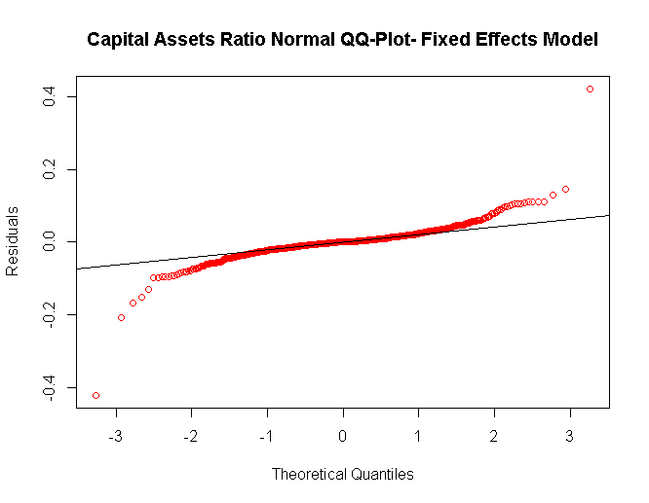 | 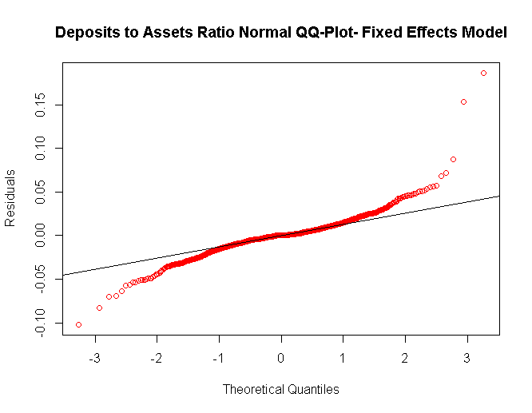

For more detailed, but simplified discussion on the derivation and application of the within-estimator, refer to Roberts and Whited (2013), Chapter (), pp. 558.

